**LEADS =** A Lead is a record that contains two bits of information. It contains some information about a company and it has fields that contain information about a person. In simple words, lead is a, leads are the people we have never sold or targeting to sell.

We can convert leads into account, contact or opportunities once it is qualified. After converting, it will be present in lead reports.

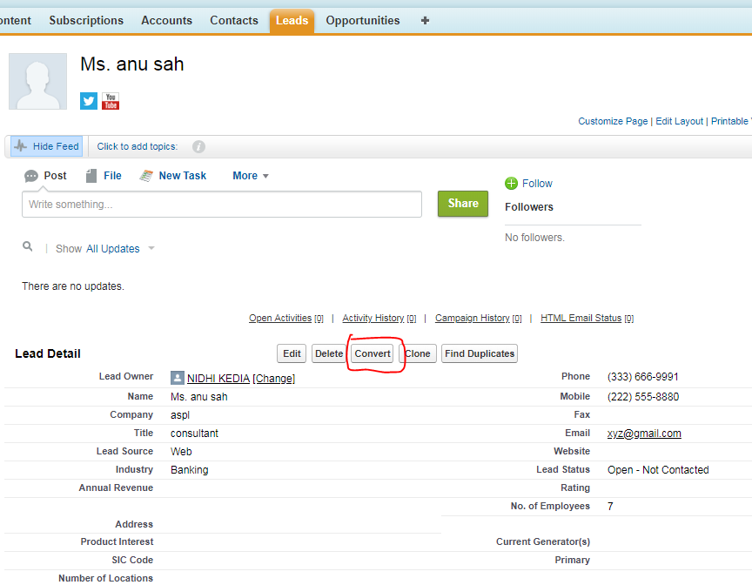

**ACCOUNTS, CONTACTS & OPPORTUNITIES=** Account is considered as business entity. Accounts have a company name, address, phone number, etc., and can have a hierarchy with several layers of Parents and Children to support complex organizational structures and reporting requirements.

**Contacts** are the people associated with or without account whom we may want to sell. Contacts can associate to one or many accounts.

**Opportunities** represent a transaction between your company and an Account. Opportunities needs to be associated with any existing accounts. One must provide value(amount) and close date. It must have a stage. The Opportunity Stage is used to identify and track the various steps an Opportunity “travels” during the sales process.

**PRODUCT=** It is an individual item or service which can be sold to customers using opportunities. It must be associated with an active price book if its planned to sell. It can exist in multiple price book. Product is added to opportunities only if they are active.

**Price Book** represent group of customers where we wish to sell product. Default is **standard price book**. One must have at least one active price book to sell any product.

**Price Book Entry** holds standard price or list price for the product which are intended to charge against active price books. It’s an associated entity to products and price book.

**Product Family** is a picklist to categorize your products. For example, if your company sells both hardware and software, you can create two product families: Hardware and Software.

Setup>Customize>Products>Fields>Product Family

**NOTES**

* If we are adding multiple products in opportunities, then it is compulsory that all those products belong to the same price book.
* We cannot have two different products from two different price books under one single opportunities.
* While adding product to any opportunities, system will first ask which price book user wants to refer.
* When user adds product to opportunities, it is call opportunity line item.
* If we want to create picklist, then we need to create object then

### Setup>Customize>Contacts>Contact Custom Fields & Relationships

### There click on the custom object created by you. Select data-types and done.